EXP NO 3
BUS TICKET BOOKING SYSTEM

Aim
To develop a Bus Ticket Booking System webpage that allows passengers to enter their details, select the source, destination, journey date, and seat number, and confirm their booking.
Procedure
- Create the webpage using HTML and CSS.
- Add navigation links and a booking form.
- Provide input fields for passenger name and journey date.
- Add dropdown menus for source, destination, and seat selection.
- Use JavaScript to validate the inputs and display booking confirmation.
- Run the webpage in a browser and verify the output.
Code
<!DOCTYPE html>
<html>
<head>
<title>Bus Ticket Booking</title>
<style>
body{font-family:Arial;margin:0;background:#f4f4f4;}
header{background:#0066cc;color:white;padding:15px;text-align:center;}
nav{background:#004c99;padding:10px;text-align:center;}
nav a{color:white;text-decoration:none;margin:15px;font-weight:bold;}
.container{width:320px;margin:30px auto;background:white;padding:20px;border-radius:10px;box-shadow:0 0 10px gray;}
h2{text-align:center;color:#0066cc;}
input,select,button{width:100%;padding:8px;margin:8px 0;}
button{background:#0066cc;color:white;border:none;cursor:pointer;}
button:hover{background:#003d80;}
#result{margin-top:15px;color:green;font-weight:bold;}
footer{background:#004c99;color:white;text-align:center;padding:10px;margin-top:20px;}
</style>
</head>
<body>

<header>
<h1>🚌 Bus Ticket Booking System</h1>
</header>

<nav>
<a href="#">Home</a>
<a href="#">Book Ticket</a>
<a href="#">Contact</a>
</nav>

<div class="container">
<h2>Book Your Journey</h2>

<input type="text" id="name" placeholder="Passenger Name">

<select id="from">
<option value="">From</option>
<option>Chennai</option>
<option>Coimbatore</option>
<option>Madurai</option>
<option>Salem</option>
</select>

<select id="to">
<option value="">To</option>
<option>Chennai</option>
<option>Coimbatore</option>
<option>Madurai</option>
<option>Salem</option>
</select>

<input type="date" id="date">

<select id="seat">
<option>Seat 1</option>
<option>Seat 2</option>
<option>Seat 3</option>
<option>Seat 4</option>
<option>Seat 5</option>
</select>

<button onclick="book()">Book Ticket</button>

<p id="result"></p>
</div>

<footer>
© 2026 Bus Ticket Booking
</footer>

<script>
function book(){
let n=name.value,f=from.value,t=to.value,d=date.value,s=seat.value;
if(n==""||f==""||t==""||d==""){
alert("Please fill all details");
}
else{
result.innerHTML="<b>✅ Booking Confirmed</b><br><br>"+
"Passenger : "+n+"<br>"+
"Journey : "+f+" ➜ "+t+"<br>"+
"Date : "+d+"<br>"+
"Seat No : "+s;
}
}
</script>

</body>
</html>

Output
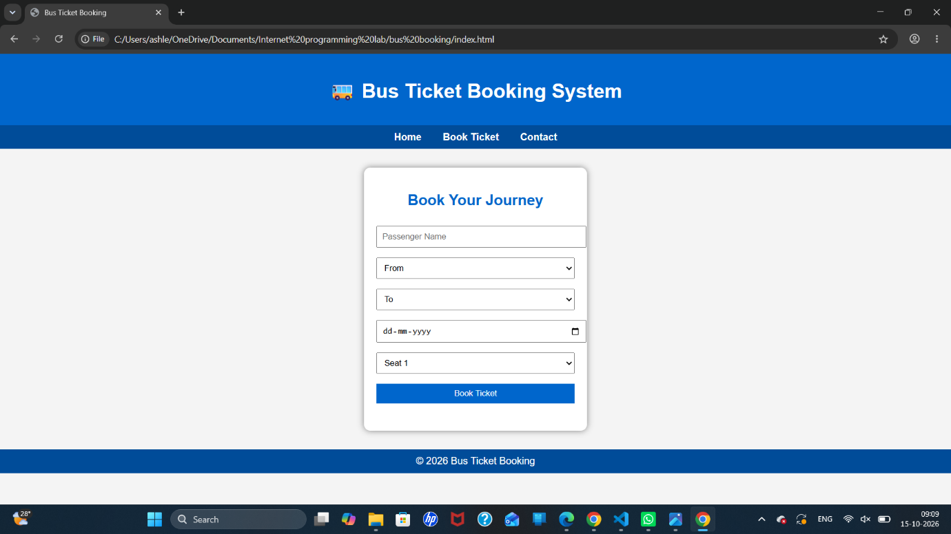

Result
Thus, the Bus Ticket Booking System webpage was created successfully with passenger details, journey selection, seat selection, input validation, and booking confirmation.

